## **LAB 3**

## **OBJECTIVE:** To implement Circular Singly Linked List and perform various operations in C programming.

**THEORY:**

A "circular singly linked list" is a type of linked list where each node only points to the next node in the sequence, but the last node in the list points back to the first node, creating a continuous loop or "circle" allowing for traversal from any point in the list back to the beginning without reaching a null pointer; essentially, it's a singly linked list where the last node connects to the first node.

. 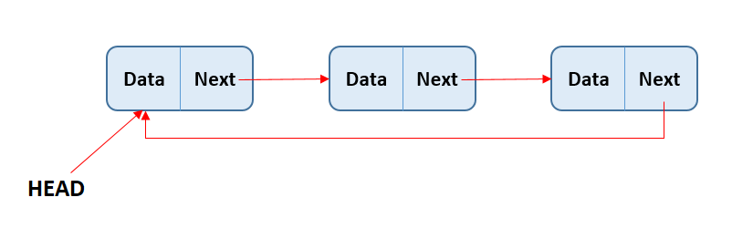

Operations to perform in circular singly linked list are mention bellow:

1. Insert Operation
   1. Insert at beginning
   2. Insert at Position
   3. Insert at End
2. Delete Operation
   1. Delete at beginning
   2. Delete at position
   3. Delere at End
3. Traverse Operation
   1. Display items

## PROGRAMS

*#include <stdio.h>*

*#include <stdlib.h>*

*#include <conio.h>*

*// Structure for Singly Circular Linked List Node*

*struct Node {*

*int data;*

*struct Node *next;*

*};*

*typedef struct Node node;*

*node *head = NULL;*

*// Function to create a new node*

*node* createNewNode(int item) {*

*node *newnode = (node*)malloc(sizeof(node));*

*newnode->data = item;*

*newnode->next = newnode; // Circular connection*

*return newnode;*

*}*

*// Function to insert at the beginning*

*void insertAtBeg(int item) {*

*node *newnode = createNewNode(item);*

*if (head == NULL) {*

*head = newnode;*

*} else {*

*node *temp = head;*

*while (temp->next != head)*

*temp = temp->next;*

*temp->next = newnode;*

*newnode->next = head;*

*head = newnode;*

*}*

*}*

*// Function to insert at a specific position*

*void insertAtPos(int pos, int item) {*

*if (pos < 1) {*

*printf("\n\t\t!!! Invalid Position...\n");*

*return;*

*}*

*if (pos == 1 || head == NULL) {*

*insertAtBeg(item);*

*return;*

*}*

*node *temp = head;*

*node *newnode = createNewNode(item);*

*for (int i = 1; i < pos - 1; i++)*

*temp = temp->next;*

*newnode->next = temp->next;*

*temp->next = newnode;*

*}*

*// Function to insert at the end*

*void insertAtEnd(int item) {*

*node *newnode = createNewNode(item);*

*if (head == NULL) {*

*head = newnode;*

*} else {*

*node *temp = head;*

*while (temp->next != head)*

*temp = temp->next;*

*temp->next = newnode;*

*newnode->next = head;*

*}*

*}*

*// Function to delete at the beginning*

*void deleteAtBeg() {*

*if (head == NULL) {*

*printf("\n\t!!! Empty Node list...\n");*

*return;*

*}*

*if (head->next == head) head = NULL;*

*else {*

*node *temp = head;*

*while (temp->next != head)*

*temp = temp->next;*

*head = head->next;*

*temp->next = head;*

*}*

*}*

*// Function to delete at a specific position*

*void deleteAtPos(int pos) {*

*if (head == NULL) {*

*printf("\n\t!!! Empty Node list...\n");*

*return;*

*}*

*if (pos < 1) {*

*printf("\n\t\t!!! Invalid Position...\n");*

*return;*

*}*

*if (pos == 1) {*

*deleteAtBeg();*

*return;*

*}*

*node *temp = head;*

*for (int i = 1; i < pos-1; i++)*

*temp = temp->next;*

*temp->next = (temp->next)->next;*

*}*

*// Function to delete at the end*

*void deleteAtEnd() {*

*if (head == NULL) {*

*printf("\n\t!!! Empty Node list...\n");*

*return;*

*}*

*if (head->next == head) { // Only one node*

*free(head);*

*head = NULL;*

*} else {*

*node *temp = head;*

*while ((temp->next)->next != head)*

*temp = temp->next;*

*free(temp->next);*

*temp->next = head;*

*}*

*}*

*// Function to display the circular linked list*

*void display() {*

*printf("\n\tList of data:\n\t");*

*if (head == NULL) {*

*printf("\t!!! Empty Node list...\n");*

*return;*

*}*

*node *temp = head;*

*do {*

*printf("%d -> ", temp->data);*

*temp = temp->next;*

*} while (temp != head);*

*printf("(HEAD)\n");*

*}*

*// Menu-driven Dashboard*

*void Dashboard() {*

*int choice, value, pos;*

*do {*

*system("cls");*

*display();*

*printf("\n\tEnter operation: \n");*

*printf("\t\t1. Insert at Beginning\n");*

*printf("\t\t2. Insert at Position\n");*

*printf("\t\t3. Insert at End\n");*

*printf("\t\t4. Delete at Beginning\n");*

*printf("\t\t5. Delete at Position\n");*

*printf("\t\t6. Delete at End\n");*

*printf("\t\t7. Exit\n\n");*

*printf("\tEnter your choice: ");*

*scanf("%d", &choice);*

*switch (choice) {*

*case 1:*

*printf("\n\tEnter value to insert: ");*

*scanf("%d", &value);*

*insertAtBeg(value);*

*break;*

*case 2:*

*printf("\n\tEnter position: ");*

*scanf("%d", &pos);*

*printf("\tEnter value to insert: ");*

*scanf("%d", &value);*

*insertAtPos(pos, value);*

*break;*

*case 3:*

*printf("\n\tEnter value to insert: ");*

*scanf("%d", &value);*

*insertAtEnd(value);*

*break;*

*case 4:*

*deleteAtBeg();*

*break;*

*case 5:*

*printf("\n\tEnter position: ");*

*scanf("%d", &pos);*

*deleteAtPos(pos);*

*break;*

*case 6:*

*deleteAtEnd();*

*break;*

*case 7:*

*printf("\n\tExiting program...\n");*

*break;*

*default:*

*printf("\n\tInvalid choice! Please try again.\n");*

*}*

*printf("\n\tPress Enter to continue...");*

*getch();*

*} while (choice != 7);*

*}*

*int main() {*

*Dashboard();*

*return 0;*

*}*

Output:

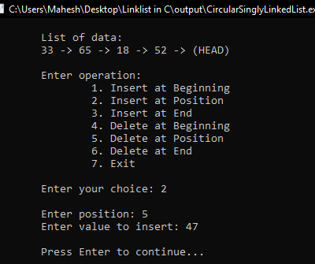 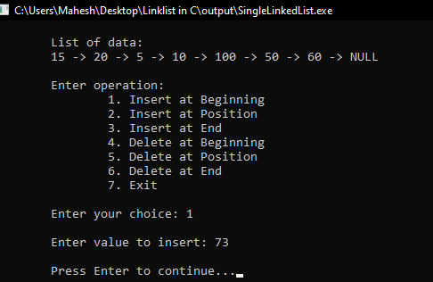

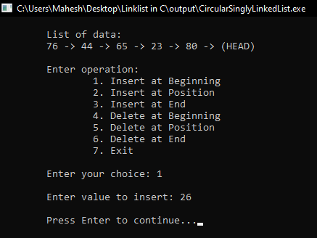 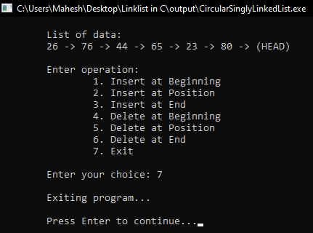

RESULTS AND DISCUSSION:

The stuents are successful to write code for circular single linked list in C programming. This program helps to understand basics of Data structure to create CSLL. The program have menu driven functioality to perform operations in circular singly linked list.

CONCLUSION:

This laboratory exercise provided a hands-on experience in DSA. Students gained practical knowledge of implementing basic in circular singly linked list and now better equipped to undertake more complex programming tasks in the future.